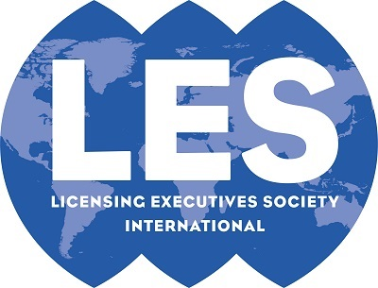

LESI Committee Mid-Year Report
2022-2023
Due: Nov. 4, 2022

Committee Name | the LESI Dispute Resolution Committee
Chairs and Vice Chairs | Chair: Tilman Müller-Stoy (LES Germany)  Vice Chair: Marco Tong (LES China)

Action Plan
Recent:

- UP & UPC Industry (European and non-European) & Patent Attorney Strategy Webinar
- Person in Charge: Alexander Haertel (with Marleen von den Horst, Thomas Adocker)
- Date: November 9, 2022

- Deep Dive UP Filing Strategies
- Person in Charge: Richard Pinckney (with Tom Gaunt)
- Date: Planned on November 23, 2022 (not sure if it is done or not)

- Various write-ups for LESI Global News on committee activities

Upcoming:

- UPC & UP Impact on Licensing & Tech Transfer (together with EPLAW)
- Person in Charge: Eszter Szakacs, Jean-Hyacinthe de Mitry
- Date: tbc

- Various UPC & UP webinars, see attachment

- ADR in IP Disputes Curse or Blessing
- Person in Charge: Isabelle Romet (with Richard Pinckney and Tilman Müller-Stoy)
- Date: February 7, 2023

- Support of Thought Leadership Program – ADR Track

- Workshop LESI Montreal:
- UPC litigation & UP prosecution – chances, risks, strategies
- Tuesday May 2, 11:00-12:30
- Moderator: Tilman Müller-Stoy

Conference Calls Conducted and Topics Discussed
- July 8, 2022, two main issues discussed: UPC and ADR will be focused;

- July 27, 2022, three main topics discussed:UPC& UP impacts on Licensing & transactions, UPC Litigation and ADR, persons in charge of Webinars to be held also decided;

- September 13, 2022, further and more detailed discussion on schedules, organization and leadership of 4 webinars; other actions also discussed, including various work shops ;

- October 11, 2022: I think I missed the meeting so I can not make any input;

- November 3, 2022, detailed discussion of ADR Webinar, including but not limited to webinar topics, potential speakers and schedules.

Specific Topics / Reporting items

Prompting Questions:

- Are there issues or projects for approval that you would like to bring to the attention of the LESI Board? (The LESI Board meets monthly. Please provide a short description of your issue and when it would be timely to add to an upcoming board agenda)
NO

- Have you conducted any webinars this year? Did you submit any proposals for LESI2023? If so, please list them.
SEE ABOVE

- Have you reached out to other LESI committee leaders to discuss areas of common interest / collaboration?
YES, EUROPEAN COMMITTEE RE UPC & UP WEBINARS

- Have you accessed your committee page and/or posted any notes, committee news or initiated discussions on http://connect.lesi.org?
YES BY EMAIL

- What have you done to increase members of your committee this year?
We discussed to bring new members through new operating companies in new regions and industry branches. We already seen new membership applications from companies such as ZTE and from the UK and India.

- Would you like to host an in-person meeting of your committee at LESI2023 in Montreal?
Yes, we will do a “best of” DRC activities workshop at LESI 2023 in Montreal.

